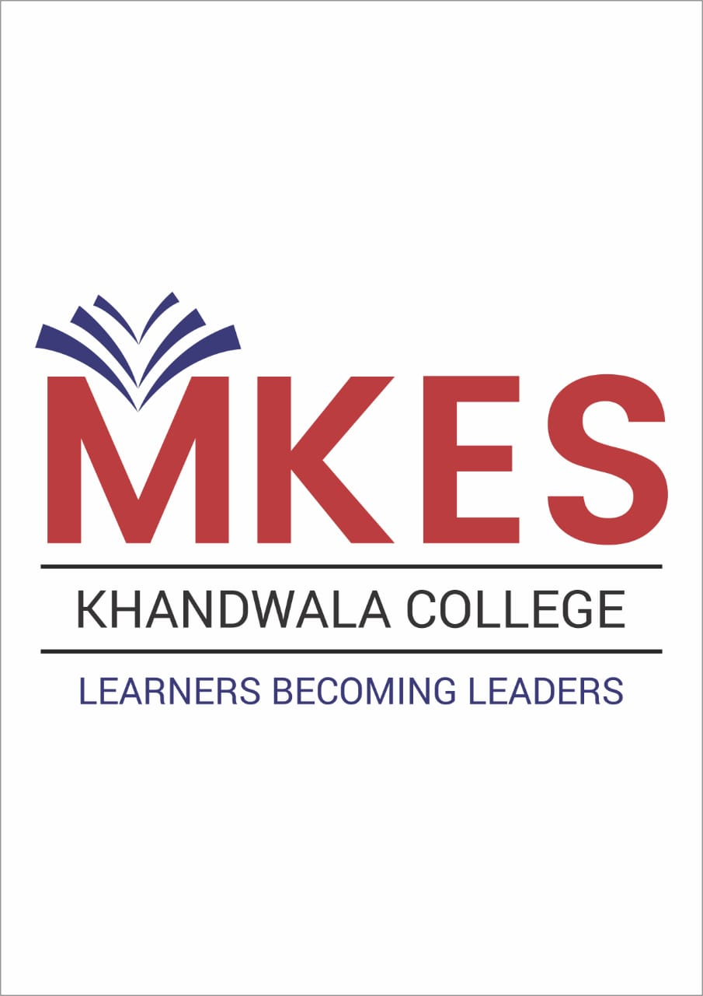

# NAGINDAS KHANDWALA COLLEGE

# (EMPOWERED AUTONOMOUS COLLEGE)

**NOTICE**

**24-25-11/UG/ /NT-2**

**General Electives for TY students in academic year 2024-25**

Students of TYBCom, TYBAF, TYBAMMC, TYBBI, TYBFM and TYBMS who have not yet enrolled for the General Elective (GE) courses are requested to register for the same urgently. These students can choose any two out of the four GE courses mentioned in Annexure I. The registration links for these four courses are also given in the Annexure. The last date for filling up the registration form is **November 29, 2024**. After filling up the google form, students must join the whatsapp group of their respective course through the link given at the end of the google form. Joining the whatsapp group is compulsory since all communication regarding lectures, exams, projects, etc. will be informed through the whatsapp group. Lectures for these courses will tentatively begin from the first week of December 2024. Students who have already registered for these courses should not register again.

The fees for each course of 2 credits is Rs.600.

As mentioned in the earlier circular dated July 19, 2024, students participating in co-curricular and extracurricular activities can earn 2 credits if they satisfy the conditions stated in Table 2 (refer Annexure II). In that case, they have to choose only 1 General Elective course for completing their balance 2 credits.

Please note that it is compulsory for all third-year students of the above-mentioned programmes to earn these 4 credits, failing which they will get an ATKT in their final grade card.

Date: 18-11-2024 Prof. (Dr.) Moushumi Datta

Principal

**Annexure I**

**TY Generic Electives (Credit Courses)** **(2 credits each)**

|  |  |  |  |  |
| --- | --- | --- | --- | --- |
| **Sr. No** | **Name of the course** | **Course Coordinator** | **Contact number** | **Google form link** |
| 1 | Understanding Pollution through Mobile Application | Mr. Ashley Fernandes, Dept. of Geography | 9920471916 | <https://forms.gle/y4C3J2mmR1kwyQHE9> |
| 2 | Visual Merchandising | Mr. Parth Davda, Apparel Design | 9172404999 | <https://forms.gle/ferUKTWPZ97tihWUA> |
| 3 | Stylisation/ Styling | Mr. Parth Davda, Apparel Design | 9172404999 | <https://forms.gle/iEigUiQExR1YxYWT7> |
| 4 | Quantum GIS (QGIS) and its application | Dr. Amrita Agarwal, Dept. of Geography | 9594942686 | <https://forms.gle/NKwdAdG3oMCm1Z5e9> |

**Annexure II**

**Participation in Co-curricular and Extracurricular activities (2 credits each)**

Students satisfying any one of the criteria listed below will earn 2 credits **on submission of a report of their activities/achievements to their respective unit In-charges**: -

|  |  |  |
| --- | --- | --- |
| **Category** | **Criteria** | **Course Code** |
| NSS | Registered with NSS unit of Khandwala College, who have completed 120 hours with participation at the rural camp, and authorities in charge of NSS at college level have recommended their name for exemption | 236UGENS |
| Sports | Won prizes at University, State, National or International level in any sports activity- individual or team - and their name has been recommended by authorities in charge of Gymkhana at college level | 236UGESP |
| NCC | Enrolled for NCC unit of Khandwala College, have completed mandatory hours of training and have attended all programs of NCC at Khandwala College and their name has been recommended by authorities in charge of NCC at college level | 236UGENC |
| Cultural | Represented Khandwala College at any University Cultural Festival, won prizes and their name has been recommended by the Students Council in charge | 236UGECL |